<https://www.youtube.com/watch?v=bBFnIuqFutc>

1. **Sketch / Include Library / Manage Libraries /**

**Tools / Board / Board Manager / Heltec ESP32**

**Tools / Board / Board Manager / LoRa**

1. **File / Preferences/**

https://dl.espressif.com/dl/package_esp32_index.json, <http://arduino.esp8266.com/stable/package_esp8266com_index.json>

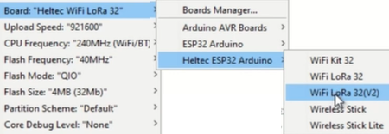

1. **Examples / Heltec ESP32 Dev / Lora / OLED_LoRaReceiver (sender)**

#include <SPI.h>

#include <LoRa.h>

void setup() {

Lora.begin(433E6);

}

if (!Lora.begin(433E6)) Serial.print(“Error”);

|  |  |
| --- | --- |
| **Sender** | **Receiver** |
| void loop(){  int val = map(analogRead(A0), 0,1024, 0, 255);  LoRa.beginPacket();  LoRa.print(val);  LoRa.endPacket();  delay(2000);  } | String inStr = “”;  void loop(){    int packetSize = LoRa.parsePacket();  if (packetSize) {    while (LoRa.available() )  {  int inChar = LoRa.read();  inStr += (char)inChar;  //int val = inString.toInt();  }  Serial.print(inStr);  inStr = “”;  LoRa.packetRssi();  } |
|  |  |